1. 新开发一个流程的时候，跑到某一个节点：“UTC时间转换为本地时间”，显示失败

BDI 后台日志显示：

]|INFO|BDI|PI_980361|No before execution found for DataStage : UTC时间转换为本地时间. Consider it pass before execution.

[2017-06-09 00:01:03,043]|ERROR|BDI|PI_980361|com.huawei.data.integration.common.DSException:

com.huawei.data.integration.common.DSException: UTC时间转换为本地时间 is failed!

at com.huawei.data.integration.core.stage.impl.DataStageCCExecution.runInternal(DataStageCCExecution.java:372)

at com.huawei.data.integration.core.stage.impl.DataStageCCExecution.access$000(DataStageCCExecution.java:77)

at com.huawei.data.integration.core.stage.impl.DataStageCCExecution$1.run(DataStageCCExecution.java:160)

at java.security.AccessController.doPrivileged(Native Method)

at javax.security.auth.Subject.doAs(Subject.java:422)

at org.apache.hadoop.security.UserGroupInformation.doAs(UserGroupInformation.java:1672)

at com.huawei.data.integration.core.stage.impl.DataStageCCExecution.runInternalMultiEnv(DataStageCCExecution.java:155)

at com.huawei.data.integration.core.stage.impl.DataStageCCExecution.run(DataStageCCExecution.java:125)

at com.huawei.data.integration.core.stage.impl.DataStageExecutionImpl.run(DataStageExecutionImpl.java:221)

at sun.reflect.GeneratedMethodAccessor1195.invoke(Unknown Source)

at sun.reflect.DelegatingMethodAccessorImpl.invoke(DelegatingMethodAccessorImpl.java:43)

原因是:修改了某中间字段,后面的字段需要重新设置，同样的如果修改了中间一个节点，后面的节点一样也要重新打开重新保存刷新（已经给BDI 确认是bdi的bug）

1. 节点字段校验的时候函数传参数字段命名要严格匹配该字段前面已经定义的输入字段。

如果匹配失败会有类似相关日志：

at java.util.concurrent.ThreadPoolExecutor$Worker.run(ThreadPoolExecutor.java:617)  
at java.lang.Thread.run(Thread.java:745)  
Caused by: expression :  
object fire(){ FmtTime(flow.startDataTime,"yyyyMMdd");}  
GRAMMER ERROR {beginErrorLine(start from 1) : 1, beginErrorPosInLine(start from 0) : 28, endErrorLine(start from 1) : 1, endErrorPosInLine(start from 0) : 41, error symbol : startDataTime, error message : Unknow attribute : startDataTime }

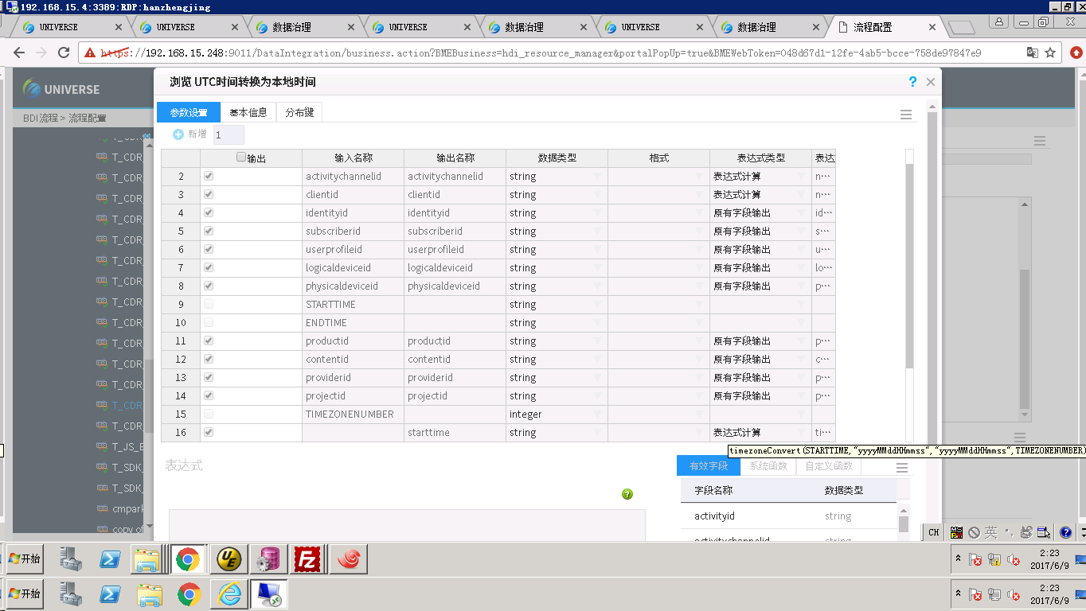

1. nameNode 节点磁盘不足
2. 巡检发现/opt/huawei/Bigdata/apache-tomcat-7.0.63/webapps/web/WEB-INF/bak 文件有量的*.tar.gz 文件

-rw------- 1 omm wheel 724M Jun 19 07:34 V100R002C50SPC200_HDFS-hacluster-FSimage_20170619073117.tar.gz  
-rw------- 1 omm wheel 724M Jun 19 08:04 V100R002C50SPC200_HDFS-hacluster-FSimage_20170619080111.tar.gz  
-rw------- 1 omm wheel 724M Jun 19 08:34 V100R002C50SPC200_HDFS-hacluster-FSimage_20170619083107.tar.gz  
-rw------- 1 omm wheel 724M Jun 19 09:04 V100R002C50SPC200_HDFS-hacluster-FSimage_20170619090105.tar.gz  
-rw------- 1 omm wheel 724M Jun 19 09:33 V100R002C50SPC200_HDFS-hacluster-FSimage_20170619093059.tar.gz  
-rw------- 1 omm wheel 725M Jun 19 10:04 V100R002C50SPC200_HDFS-hacluster-FSimage_20170619100123.tar.gz  
-rw------- 1 omm wheel 725M Jun 19 10:33 V100R002C50SPC200_HDFS-hacluster-FSimage_20170619103057.tar.gz  
-rw------- 1 omm wheel 726M Jun 19 11:04 V100R002C50SPC200_HDFS-hacluster-FSimage_20170619110120.tar.gz  
-rw------- 1 omm wheel 726M Jun 19 11:34 V100R002C50SPC200_HDFS-hacluster-FSimage_20170619113123.tar.gz  
-rw------- 1 omm wheel 726M Jun 19 12:04 V100R002C50SPC200_HDFS-hacluster-FSimage_20170619120127.tar.gz  
-rw------- 1 omm wheel 727M Jun 19 12:34 V100R002C50SPC200_HDFS-hacluster-FSimage_20170619123103.tar.gz  
-rw------- 1 omm wheel 727M Jun 19 13:04 V100R002C50SPC200_HDFS-hacluster-FSimage_20170619130105.tar.gz  
-rw------- 1 omm wheel 728M Jun 19 13:33 V100R002C50SPC200_HDFS-hacluster-FSimage_20170619133058.tar.gz  
-rw------- 1 omm wheel 728M Jun 19 14:04 V100R002C50SPC200_HDFS-hacluster-FSimage_20170619140108.tar.gz  
-rw------- 1 omm wheel 728M Jun 19 14:34 V100R002C50SPC200_HDFS-hacluster-FSimage_20170619143109.tar.gz  
-rw------- 1 omm wheel 728M Jun 19 15:04 V100R002C50SPC200_HDFS-hacluster-FSimage_20170619150133.tar.gz  
-rw------- 1 omm wheel 728M Jun 19 15:33 V100R002C50SPC200_HDFS-hacluster-FSimage_20170619153059.tar.gz  
-rw------- 1 omm wheel 728M Jun 19 16:03 V100R002C50SPC200_HDFS-hacluster-FSimage_20170619160057.tar.gz  
-rw------- 1 omm wheel 728M Jun 19 16:34 V100R002C50SPC200_HDFS-hacluster-FSimage_20170619163123.tar.gz  
-rw------- 1 omm wheel 729M Jun 19 17:03 V100R002C50SPC200_HDFS-hacluster-FSimage_20170619170058.tar.gz  
-rw------- 1 omm wheel 729M Jun 19 17:34 V100R002C50SPC200_HDFS-hacluster-FSimage_20170619173124.tar.gz  
-rw------- 1 omm wheel 729M Jun 19 18:04 V100R002C50SPC200_HDFS-hacluster-FSimage_20170619180122.tar.gz  
-rw------- 1 omm wheel 729M Jun 19 18:34 V100R002C50SPC200_HDFS-hacluster-FSimage_20170619183121.tar.gz  
-rw------- 1 omm wheel 723M Jun 19 19:04 V100R002C50SPC200_HDFS-hacluster-FSimage_20170619190121.tar.gz

2）解决方法

http://support.huawei.com/ehedex/hdx.do?lib=DOC1000126368YZF1206A&docid=DOC1000126368&v=03&tocLib=DOC1000126368YZF1206A&tocV=03&id=ZH-CN_TOPIC_0045557888&tocURL=resources%2Fzh-cn_topic_0045557888.html&p=t&fe=1&ui=3&keyword=%252525E7%252525A9%252525BA%252525E9%25252597%252525B4&clientWidth=1325&browseTime=1497921709451